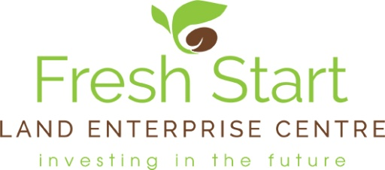

Fresh Start
South West Peak Uplands Academy 2017
Application Form
Applications open from: 29th July 2017 until 27th September 2017
FS12

Return your completed form to: info@freshstartlandenterprise.org.uk or send to
Academy Applications, FSLEC, Highfield Lodge, Highfield, Leek, Staffordshire ST13 8SG by no later than 5pm 27th September 2017.

Essential information:
Applicants, if successful should be able to attend the complete academy programme. A fee of £120 (no VAT) per successful applicant will be payable once a place has been officially offered from the selection panel. If you have any questions over this fee please do speak to us.

For further information or if you have any questions please contact:
Alison Rickett, Academy Co-ordinator at Fresh Start Land Enterprise Centre
Tel: 07771 911 905 or email Alison@freshstartlandenterprise.org.uk

The Academy commences on 7th November 2017. A full list of the academy dates and the programme can be found at www.freshstartlandenterprise.org.uk

FSLEC will contact you by 12th October 2017 at the latest to let you know the results of the application process.

Name

Address

Landline

Mobile

Email

Date of birth
(The Academy is open to applicants aged 18 years and over)

Please complete the questions on the following pages as fully as possible.

Previous Education/Training - please tick as appropriate

GCSES/ ‘O’ levels

AS levels

A levels

Other secondary school certificate

Further /Higher Education - please tick and list title of course/s

National Diploma _______________________________________________

Higher National Diploma _______________________________________________

Degree _______________________________________________

Other _______________________________________________

Please list any other training courses that you have taken that you feel are relevant.

Please give a brief outline of any relevant work experience from within and outside the uplands industry, including for example, business management, joint ventures or contracting.

What are your aspirations for the future, especially over the next 5 years?
(This is applicable if you are currently running a business or looking to start up in business.)

What do you see as the main challenges to you personally in starting up a business or taking over a business within the uplands sector?

What are the key areas of help/advice you are looking for to move forwards with your own business?

How do you see the South West Peak Uplands Academy 2017 helping you on your way to your goal?

South West Peak Uplands Academy 2017 is supported by:

Bagshaws

Farming Life Centre

J. Metcalfe Green Hills Cheviots

National Trust

NFU

Peak District National Park

South West Peak Project

